Online External Studies and Automatic Credit Granting in Sona

Online external studies are online studies which are not hosted within Sona, but
instead reside on an external survey website such as Qualtrics. This is different from online survey studies where an online survey is set up directly in Sona and no other website is involved.

If you are using an online survey tool to collect data for your final year project, it can often
be impossible to work out if a participant has actually completed your survey once they have signed up. This in turn makes it difficult to know if you can grant them credit or not. In order to remove this ambiguity it is useful to implement some method of linking the
participant’s sign-up in the system to your online study, so you know who to grant credit
to. One simple way to do this is to ask the participant’s name (or some other identifying
information) that will make it easy to locate their sign-up within the system and grant
them credit once they have completed your online study. However a way which is more reliable and offers anonymity also, is to use the External Study Credit Granting feature,
where the participant receives credit automatically as soon as they finish the study. This is accomplished by having the external study notify the system that the participant has completed the study, and thus deserves credit. It also saves you, as the researcher, from having to grant credit manually.

At the University of Huddersfield the most commonly used external online survey tool is Qualtrics (please contact the Psychology Technicians if you need an account setting up). To set up automatic credit granting for your Qualtrics survey a number of steps have to be followed:
- When you create a Qualtrics survey, a survey link is created which you can send to participants. You need to add this link to the Study URL box in Sona when you add your study to Sona. Once you have done this you then need to include the text ?id=%SURVEY_CODE% at the end of the URL:
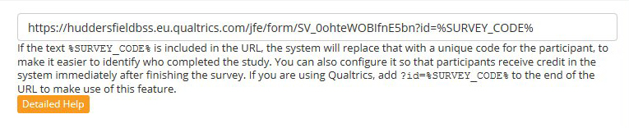
- You should then see in ‘Study Information’ a URL labelled ‘Qualtrics Re-direct to a URL’:

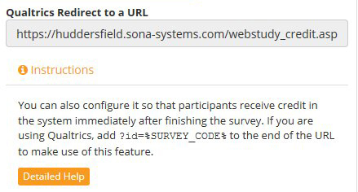
Now you need to go to your Qualtrics Survey to do the next part.

- In your Qualtrics survey go to ‘Survey Flow’ – ‘Add a New Element’ and, click on ‘Embedded Data’.

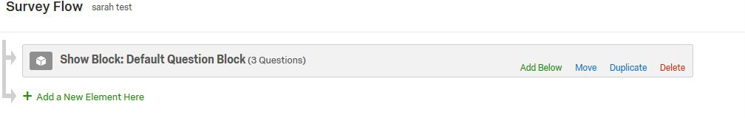
At this point type in ‘id’ and save your changes:
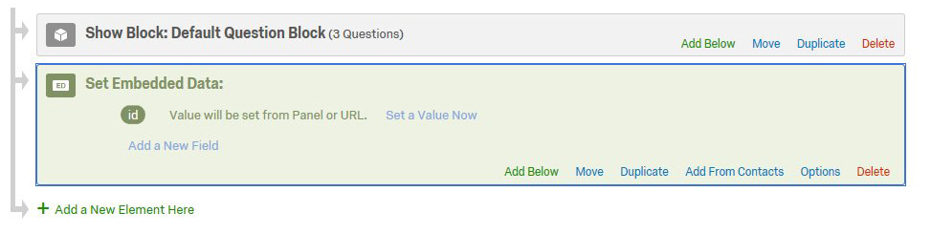
- Next, go to ‘Survey Options’ – ‘Survey Termination’ and, select ‘Redirect to a full URL’. In the box add the URL from Sona labelled ‘Qualtrics Redirect to a URL’ (you can just copy and paste this direct from Sona). Click on Save – this is now set up.

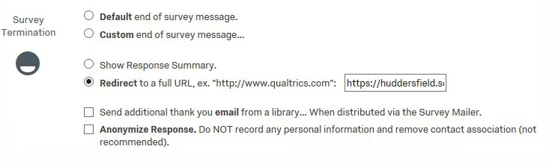
Testing External Credit Granting
Before you launch your survey it is probably wise to check the automatic credit granting process is working as it should. To do so follow the steps below:
- Go back to your Sona study and go the Study Information page. Click on ‘Sample Link with Embedded ID code’:


(If this link does not appear then this indicates something has been set up incorrectly. If it is not visible check that you have the study set up as an Online External Survey Study. If yes and it is still not visible, then check you have ‘%SURVEY_CODE%’ in the study URL field. Any further problems, contact the Psychology Technicians).

- Click on the link and you will be able to take your survey as if you were a participant. When you get to the end of the survey you should be redirected back to Sona where you should see the message - ‘No credit given, because you are not a participant, and therefore cannot sign up for this study’:
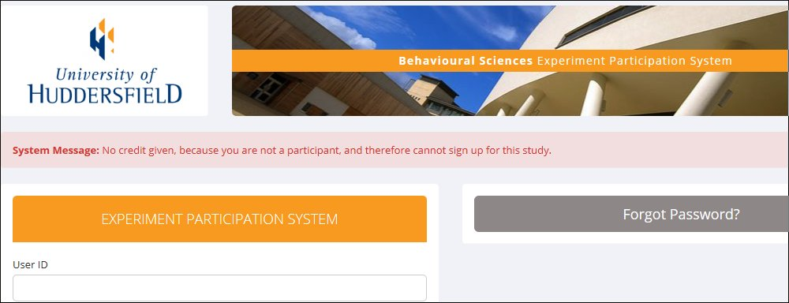

If the above doesn’t appear you need to go back through the steps and check you have followed them all correctly. If you have any problems you cannot resolve, again, please contact the Psychology Technicians.

The process is now complete and your survey can be launched.

